Jay M. Baraban MD, PhD
jay.baraban@gmail.com
January 2007

GENES AND BEHAVIOR

Overview
One of the most fascinating topics in neuroscience is the role that inheritance plays in determining one’s behavior. This topic has many facets, ranging from the philosophical discussion of “free will vs. determinism”, to individual responsibility for maladaptive behaviors, such as smoking or compulsive gambling, to the legal culpability for criminal behaviors that may have a genetic component. Rather than providing a comprehensive examination of this immense field, we will explore key concepts and discoveries that form the foundation for this ongoing area of research.

As we are not assuming that students have any special background in genetics or in behavior, we will introduce the basic genetic and behavioral concepts needed to understand how the role of inheritance on behavior is evaluated.

Objectives

- To understand how “twin” studies can be used to assess the role of inheritance in behavior.
- To understand the contribution that “forward” and “reverse” genetics make to this field.
- To understand how linkage analysis can be used to identify genes involved in neurological diseases.
- To understand how single nucleotide polymorphisms can contribute to behavioral phenotypes.

Evidence that personality and behavior have a genetic component
In a simplistic sense, genes determine all behavior, since they provide the blueprint for brain development and function, which controls all behavior. However, that formulation sidesteps the key issues addressed by this field. A core concept in genetics is that, except for identical twins, every individual has a different genetic make-up. All humans have the same cohort of genes, but there are millions of sequence variations in each individual genome that give it a characteristic “fingerprint”. Accordingly, a more incisive way to formulate the question is: What aspects of an individual’s behavior can be attributed to their genetic make-up and how much to environmental influence? Of course, the question is more complex than that because it is safe to assume that an individual’s capacity for learning, i.e. the ability to change behavior in response to experience, is itself affected by genes. Nevertheless, to a first approximation, one can ask whether the differences in genetic make-up that presumably account almost completely for differences in eye color, nose shape, etc., play a large role in specifying intelligence and behavior or whether these are largely outweighed by environmental influences.

To address this basic question, Francis Galton, working in the late 1800s, took advantage of the notion that close relatives have more similar genomes than distant or unrelated individuals. He found that individuals defined as having “genius” were more likely to have close relatives with high mental ability than expected by chance. More importantly, he introduced the concept of studying identical twins to determine the role of inheritance in behavior. Traits that show a higher degree of concordance between identical twins compared to fraternal twins were inferred to have a high genetic component. While this approach does not control perfectly for “environment”, it seems reasonable to assume that the environment shared by identical and fraternal twins would be similar. However, this lingering uncertainty has led to studies involving identical twins that have been reared apart from a young age, as it can then be assumed that concordance under those conditions can be attributed to inheritance rather than similar environmental conditions.

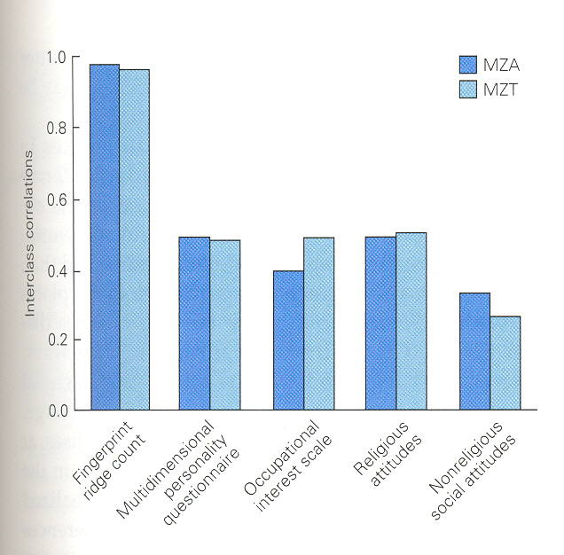
(Kandel, figure 3-3)

Overall, these types of twin studies have led to the conclusion that even though behavior is more susceptible to environmental influences than physical features such as fingerprint ridge count, a substantial component of behavioral measures, such as personality features, are attributable to inheritance.

The observation that “genius” or personality style has a genetic component is of some interest and validates what pet breeders have known for ages, i.e. that domesticated animals can be “bred” for certain desirable behavioral traits, aggressiveness or docility, loyalty, etc. However, arguably a more important contribution of this approach has been its ability to ask whether behavioral diseases, such as schizophrenia or manic-depressive illness have genetic components or not. Are these diseases produced by environmental influences, perhaps viral infection, or are they inherited? Applying this approach to schizophrenia and bipolar illness have yielded the striking finding that both have strong genetic components, with concordance among identical twins of approximately 50%, while fraternal twins or siblings have a concordance of only approximately 20%. Thus, these findings provide critical evidence that these mental illnesses have a “biological” basis.
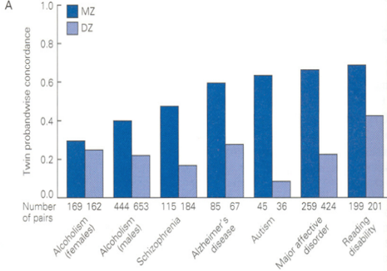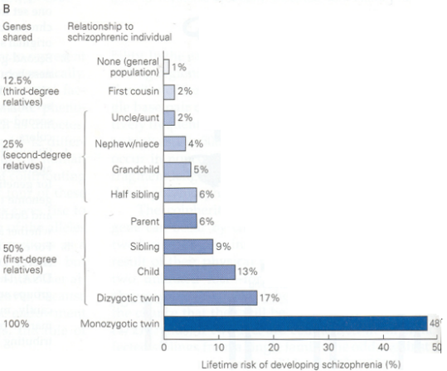
(Kandel, figures 3-15A & B)

Where to look: Reverse and Forward Genetic Approaches
Given that humans have approximately 30,000 genes and that about half of them are expressed in the nervous system, how does one begin to understand which genes control behavior and which mutations or variations predispose to susceptibility for schizophrenia or other behavioral abnormalities. Naively, there are two ways to attack this problem, either one can study how variations or mutations in a specific gene may affect behavior, or one can take a specific behavior and ask which genes are critical for mediating this behavioral response. These general approaches are called “reverse” and “forward” genetics, respectively. Seymour Benzer one of the pioneers in molecular biology took the bold step of trying to apply “forward” genetics to analyzing behavior. As he clearly needed an organism that has a short generation time in order to evaluate the impact of genetic mutations, he chose fruit flies as a model organism. He exposed Drosophila to mutagens and then isolated mutant strains that displayed abnormal behavioral responses. This new approach has spawned an enormous field that continues to yield seminal advances in identifying genes critical for a broad range of behavioral phenomena. Two prominent examples are genes that affect circadian rhythm and learning.
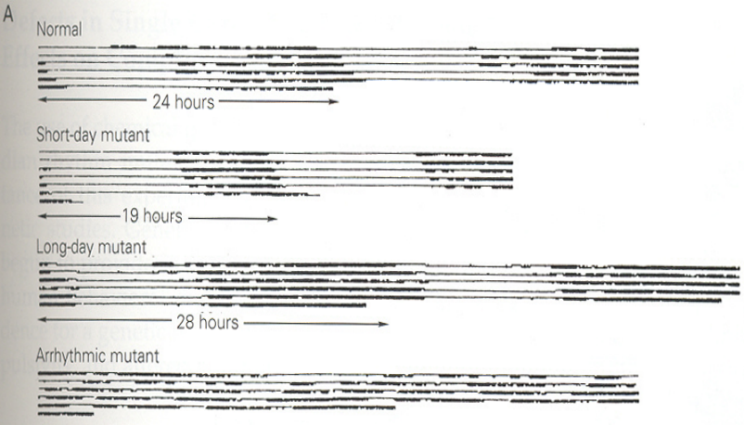
(Kandel, Figure 3-6A)
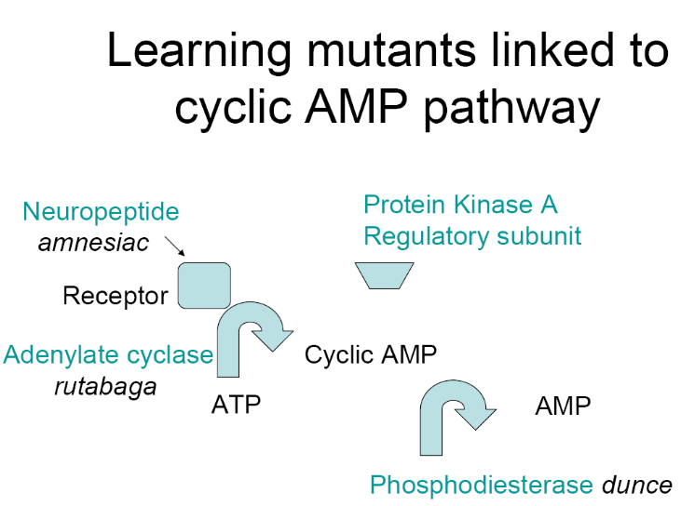

Genetic Basis of Neurogenerative Diseases
Another approach that has also been very productive is looking for naturally occurring mutations that are linked to neurological disease in one or more pedigree. In theory, this approach could be applied to any “disease” that is inherited. However, the simplest scenario would be a disease that displays dominant inheritance. Accordingly, the first target attacked with this approach was Huntington’s Disease. In this case, the goal was to determine which piece of DNA contained the deleterious gene that was being passed on from an affected individual to a child that will get the disease but not to one that will not. To track which pieces of DNA came from which parent, investigators took advantage of RFLPs, or restriction fragment length polymorphisms present throughout the genome. Using this approach they could check whether a given segment of DNA was derived from the mother or father and whether transmission from the affected parent correlated with getting the disease. By chance the investigators started with RFLPs located on chromosome 4 which turned out to be the site of the “huntingtin” gene.

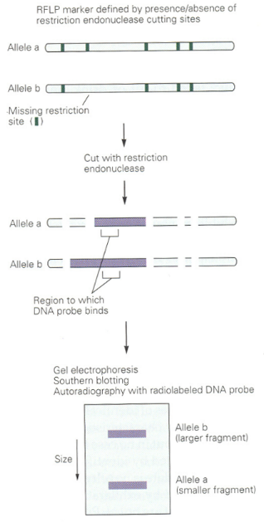

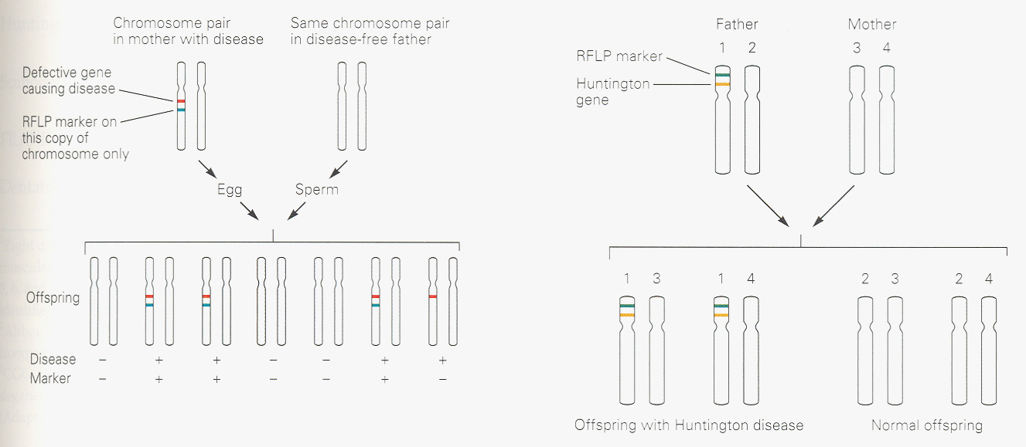

(Kandel, figures 3-11A, B, C)
Identification of the specific gene led to a surprising observation about the nature of the defect that is inherited. Rather than being a conventional deletion or substitution in the gene, the abnormal gene contains an abnormal extension of the coding region that is caused by expansion of a series of CAG codons. CAG codes for glutamine and this expanded triplet repeat produces an abnormal huntingtin protein with a stretch of 40-60 glutamines instead of the normal 20 glutamines. The precise biological role of huntingtin and how the CAG repeat expansion produces neuronal death in a specific part of the brain are still poorly understood.

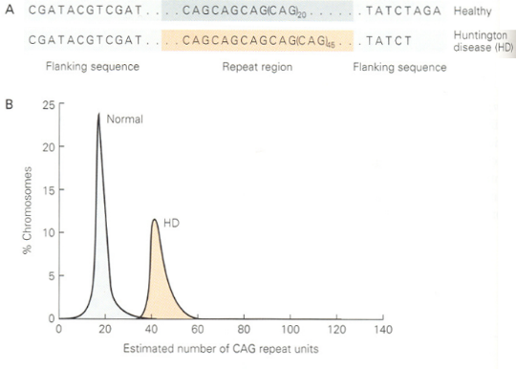
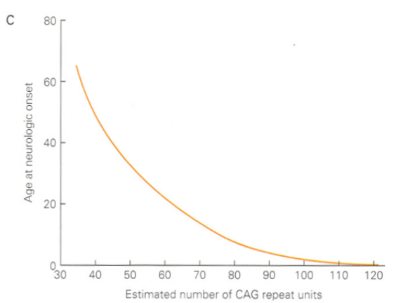
(Kandel, figure 3-12ABC)

More recently, other neurodegenerative diseases have been studied using a similar linkage-based approach. In these diseases, most cases are sporadic, i.e. do not have an obvious inheritance pattern. However, in several major neurodegenerative diseases, such as Alzheimer’s Disease, Parkinson’s Disease and ALS, there are a few percentage of patients that have a familial form of these diseases. Since the onset of symptoms is typically in adulthood, these can be propagated as dominant alleles. In contrast to Huntington’s Disease patients, all of whom have a mutation in the “huntingtin” gene, distinct pedigrees of Parkinson’s or ALS patients have different mutated genes. Analyzing how each of these genes causes the disease has led to important insights about which pathways are critical for inducing neurodegeneration and may lead to treatments that will hopefully also help the large majority of patients who have sporadic forms of the illness.

Conspiracy of Polymorphisms
Now the search is on for susceptibility genes for diseases that have more complicated modes of inheritance. It is now clear that like diabetes or asthma, most psychiatric diseases are caused by a convergence of multiple “mutations” or gene variations in a given patient or pedigree, rather than an abnormality in one particular gene. Sequencing of a given gene in many individuals has led to the realization that there are polymorphisms or normal variants in the sequence that are not typically associated with disease or abnormal behavior. However, it appears that convergence of multiple sets of polymorphisms in a given individual can increase or decrease susceptibility to a particular disease.

Over the next decade numerous examples of polymorphisms and their linkage to specific behavioral abnormalities will likely be uncovered. Rather than catalog all the linkages identified to date, I have selected one example, a relatively common single nucleotide polymorphism, or SNP, in BDNF, to illustrate several key concepts.

BDNF, or brain-derived growth factor, is a major growth factor that is secreted by brain neurons and has multiple effects on neuronal survival, as well as synaptic and morphological plasticity. BDNF knockout mice are not viable and heterozygote mice show multiple behavioral and anatomical abnormalities. Sequencing the BDNF gene in human subjects has revealed that there is a SNP which produces a single amino acid change in the N-terminal portion of the protein; changing a GUG codon to AUG produces a Val to Met switch. Hence, the SNP is referred to as V66M.

In subjects of European ancestry, the prevalence of the met allele is about 0.20, which means that about one person in 5 from that pool is heterozygotic for this allele and about 4 out of 100 (0.2 x 0.2 = 0.04) are homozygotes. Having this SNP is not associated with having a disease, however careful testing of memory function that is mediated by the hippocampus has revealed that subjects who have at least one copy of the met allele do not perform as well on a standardized memory test. The effect is small but significant. Furthermore, these subjects have a small but significant decrease in their hippocampal volume. Thus, this SNP represents one of perhaps dozens that contribute to the general variation in “normal” memory function.

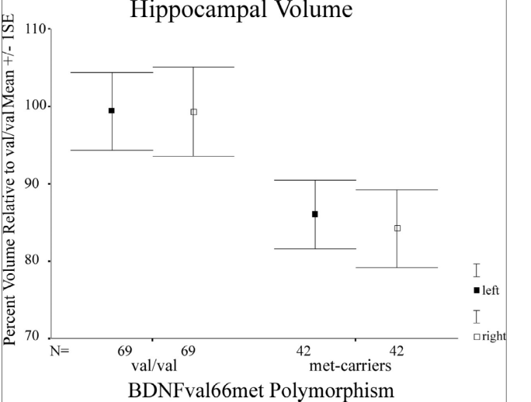 (Pezawas, figure 2)

One alternative explanation that is difficult to rule out is that it is not this specific SNP that causes these defects, but that it is associated or linked to another gene that is defective. One way to address this is to use mouse genetics to check whether “knocking-in” this SNP impairs hippocampal function in mice. This experiment has been remarkably successful in that these knock-in mice phenocopy the impairments in memory function and hippocampal size seen in subjects that have the met allele. Thus, these findings argue strongly that it is this SNP that is responsible.

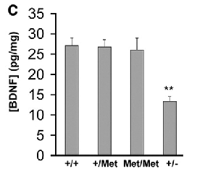
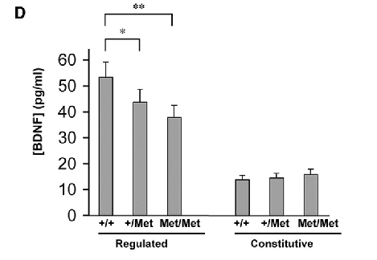

(Chen et al., figures 1C & D)
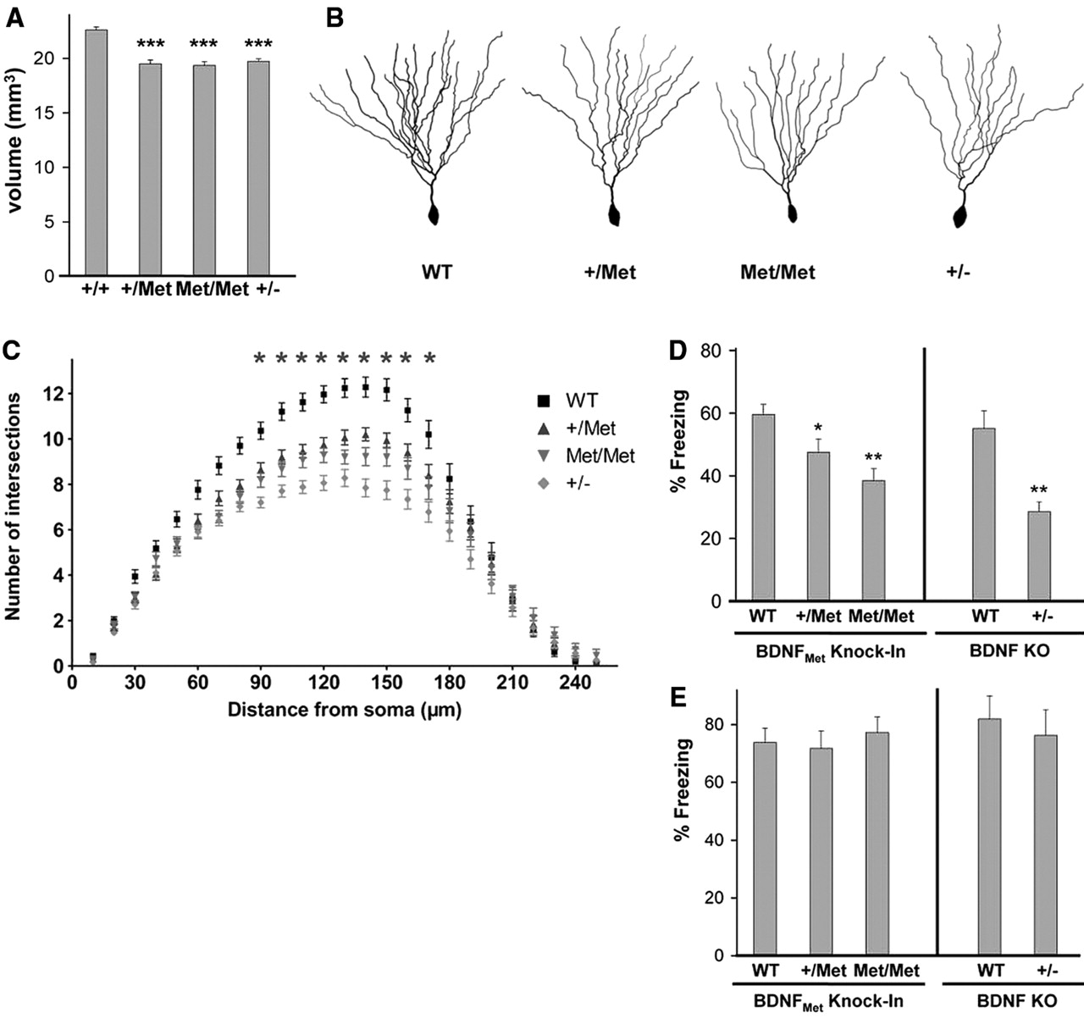

(Chen et al., figures, 2ABCDE)

Summary

Twin studies have provided compelling evidence that inheritance plays a major role in shaping behavior and in psychiatric diseases.

Linkage studies of neurological illnesses have yielded identification of specific genes or pathways implicated in triggering neurodegeneration.

Reverse genetics provides a powerful tool for assessing the function of genes implicated in synaptic function, neuronal survival and behavior.

Psychiatric diseases, which typically display low penetrance, are likely mediated by combinations of polymorphisms.

References
Kandel, Schwartz and Jessel, Principles of Neural Science, Fourth Edition, chapter 3, pp. 36-61.

Hariri et al. (2003) BDNF val66met polymorphism affects human memory-related hippocampal activity and predicts memory performance. J Neuroscience 23:66906694.

Pezawas et al. (2004) The BDNF val66met polymorphism and variation in human cortical morphology. J Neuroscience 24: 10099-10102.

Chen et al. (2006) Genetic variant BDNF (val66met) polymorphism alters anxiety-related behavior. Science 314:140-143.

Study Questions

- You have identified a gene that is expressed selectively in the hippocampus. Describe two approaches, one using mice and one in human subjects, that might help decipher its role in behavior.

- The concordance of schizophrenia in identical twins is about 50%. Given that this implies that there is a strong genetic component, what explanations can you think of for it not being 100%?

- Your friend’s mother comes down with a bizarre neurological disease in her 60’s. How can you tell if they are suffering from Huntington’s Disease? If it is, how can your friend tell if he or she may get the disease?

